Chapter 3: Methods and Techniques of Cervical Screening

Annex 1: Collection of cellular material of the uterine cervix, preparation of an adequate Pap smear

by M. Arbyn, E. McGoogan, J. Patnick

Importance and objective of the guideline on sampling:
The correct sampling of a cervical smear with appropriate equipment contributes to a significant extent to the diagnostic value of the Pap test. An inadequate smear is an important cause of false negative and false positive results. The purpose of this guideline is to minimise the proportion of unsatisfactory smears and to maximise the accuracy of the screen test.

Facilities
The cervical screening programme will invite well women. It is important that women are satisfied with the service offered to them, or they will not return for rescreening or follow up tests. Before the smear is even taken, the environment for the taking of the smear should be suitable. There should be privacy, warmth and a relaxed atmosphere. The woman must be comfortable, and there must be an adjustable spotlight for the smear taker to visualise the cervix before taking the smear.

The equipment required by the smear taker should be available prior to beginning the examination of the woman in order that the time the woman spends in what some consider to be an embarrassing position is minimised. The equipment that should be available will include gloves for the smear taker and a range of specula and sampling devices, slides, a fixative, pencil and slide carrier for conventional smears or vials and a ballpoint pen where liquid based cytology is used. The smear taker should take special care to keep the interval between taking the smear and fixing it as short as possible. So: remove top from aerosol can, check that the can is not blocked or empty. Waste disposal and sterilisation facilities will be required for when the examination is concluded.

In addition there should be leaflets available to give the woman for her information on a variety of issues that she might raise. The test request form should be properly completed.

Contra-indications for screening smears: Total hysterectomy, cervical amputation, and the presence of a suspect, macroscopically visible lesion in the area of the cervix are contra-indications for screening. In the latter case, the woman must be referred for colposcopic examination and/or biopsy.

Factors adversely affecting the quality of a smear
• menstruation, blood loss, breakthrough bleeding
• vaginal inflammation/infection
• severe genital atrophy (menopause)
• pregnancy, post-partum period and lactation
• physical manipulation or chemical irritation such as: preceding digital vaginal examination, disinfectant cream or liquid, lubricating jelly, vaginal medication (less than 48 hours before), vaginal douche (less than 24 hours before), prior colposcopy with acetic acid (less than 24 hours before), previous smear (less than 3 months before), cervical surgery (less than 3 months before)
• radiotherapy

It is essential to know these factors and reduce their effect to a minimum. Screening smears should be avoided during pregnancy and in postpartum until at least 6-8 weeks after delivery, since the quality of the preparations is poor in that period due to reactive inflammatory changes.
All relevant clinical information must be recorded on the request form.

Procedure For Taking A Cervical Sample

Explain to the woman the aim of the smear and the procedure, what to expect and give reassurance. Ask about her general health and whether she has any symptoms such as irregular bleeding or discharge. It can be helpful to note the date of the last menstrual period or any recent pregnancy. Follow any local consent protocols. Inform that sometimes the examination has to be repeated within 3 to 6 months, if the smear was not of satisfactory quality. Make a clear arrangement how the woman will be notified of the laboratory result.

For conventional smears, label the slide or slides clearly in pencil on the frosted end with the woman's surname, forename and date of birth. An identification number may be added. Other methods of marking may be removed during processing of the slide. For liquid based cytology, label the vial with the same information using a ballpoint pen.

Ensure that the woman is laying comfortably on the examination couch in either the dorsal or lateral position so as to visualise the cervix clearly and position the light. Position the light source. Avoid taking a swab before the cervical smear.

Select the largest speculum that can be inserted comfortably and bring to body temperature by warming it in the gloved hand or in tepid water. Insert the speculum along the axis of the introitus and, when half way up the vagina, rotate 90° and open when fully inserted. Lubricants are not usually necessary. If required a little tepid water or a small amount of water-soluble lubricant but this must not contaminate the surface of the cervix as this impairs the sample quality. Bring the cervix into view by gentle movement of the speculum encouraging the woman to relax. If this proves difficult, digital examination taking care not to disturb the surface of the cervix or change in position may be beneficial. The appearance of the cervix should be noted and smear takers taught the various normal and abnormal appearances of the cervix and suspicious symptoms. If a non-medically qualified person is concerned about the clinical appearance of the cervix, a medical opinion should be obtained. Do not routinely clean the cervix or take a swab before taking the sample.

The request form should be fully completed with the woman's surname, forename, date of birth and other identifying features clearly written. The number of slides or sampling technique, date of last menstrual period or recent pregnancy, and clinical observations such as irregular bleeding or suspicious looking cervix must be recorded. The smear taker should ensure that the woman has understood the procedure and is aware of when and how she will receive the test result.

Sampling the transformation zone
The precursors of cervical cancer arise mainly in the transformation zone (TZ) between the exocervical multilayer squamous epithelium and the endocervical columnar epithelium. Therefore, it is important that cell material be sampled primarily from this zone. Presence of meta-plastic squamous cells and endocervical cells, besides squamous cells, indicates that the transformation zone has been sampled but do never provide assurance that the complete TZ has been targeted.
Absence of an endo-cervical component was until recently considered as a reason to repeat the smear. Longitudinal studies have shown that women with a previous negative smear lacking endocervical cells (EC-) are not at higher risk for future cervical lesion with respect to women with a negative EC+ smear. Nevertheless presence of cylindrical cells and meta-plastic cells indicate that the target .

A single specimen is usually sufficient for a smear. The exocervical and endocervical material can be spread over a single slide.

Sampling devices
Cervical screening always requires an endocervical and an exocervical sample, taken with the appropriate instruments. Sampling the transformation zone may be carried out using a wooden or plastic spatulae of various types. Spatulae with extended tips, brooms and brushes are recommended sampling instruments (see Figure 1). Use of cotton tip applicators is not advised.

Three methods are recommended:
• cervical broom (Fig. 1c)
• Combination of a spatula (Figure 1a) for the exocervical sample and the endocervical brush (Figure 1b) for the endocervical sample. We distinguish two possible ends in the spatula (Figure 1a): Ayre pole (lower part in figure 1a) and an extended tip pole or Aylesbury end (upper part of Figure 1a).
• Extend tip spatula alone (Fig. 1a, upper end).

The cervical broom is best if the woman is pregnant or has a cervix that bleeds easily. The combination method, including the endocervical brush, is best if the squamocolumnar junction is high (often post menopausal), after cervical surgery or if there is extensive ectropion of the columnar epithelium.

Figure 1 Sampling devices: a) combined spatula with an Aylesburry end (extended tip) above and an Ayre end (below); b) endocervical brush; c) cervical broom

Sampling and preparing a conventional smear

Two procedures are detailed hereafter: one using the endocervical broom, and one using the combination of a spatula (Figure 1a) for the exocervical sample and the endocervical brush (Figure 1b) for the endocervical sample.

a. Cervical broom (Cervex-Brush®)

Endocervical cells and exocervical cells are sampled simultaneously - the long bristles pick up endocervical cells while the short bristles collect exocervical cells.
• The long bristles are positioned endocervically.
• Rotate the brush five times over 360° with gentle pressure by rolling the handle clockwise between thumb and forefinger.
• Sweep the broom lengthwise along the slide, turn over and repeat for the other side.

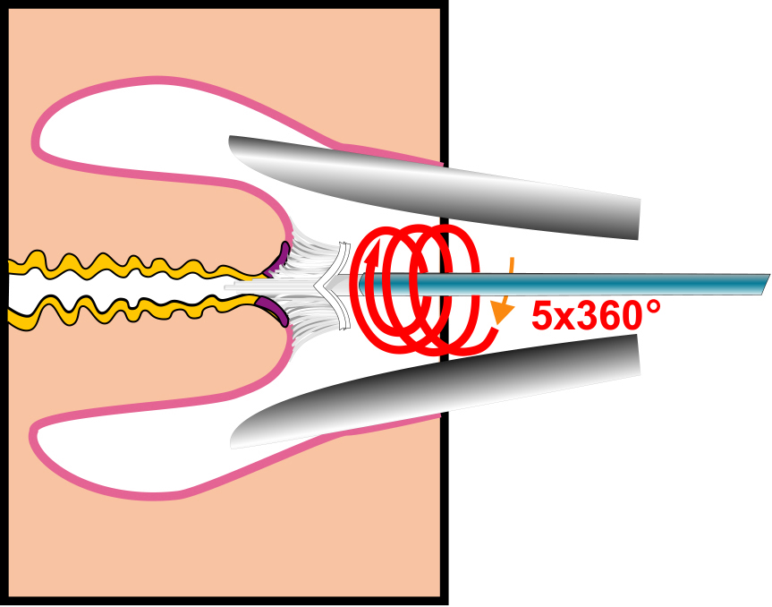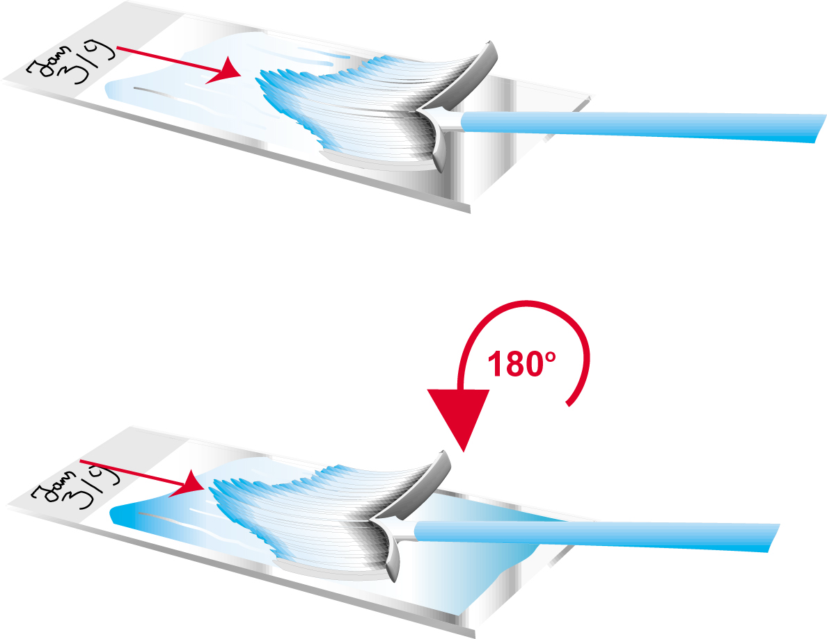
Figure 2. Cervical broom: sampling and spreading the sample on the slide.

• Immediate fixation
The fixative of choice is 95% ethyl alcohol but other appropriate fixatives may be used. The smear should be sprayed with an aerosol fixative, flooded with fixative from a dropper bottle, or placed immediately in a container of fixative that covers the whole of the cellular area of the slide. The slide should be fixed for at least 10 minutes. It should be removed from the fixative and placed dry in a slide box for transportation.

Fix the specimen immediately by spraying at a right angle from a distance of 20 cm (Figure 3). If closer, the cells are blown away or frozen, if on a slant, the material is blown into aggregates. Avoid droplet formation: so do not use too much fixative. A very fast fixation, within a few seconds, is essential to prevent drying artefacts.

It is critical that smears are fixed immediately to prevent partial air-drying which will distort cellular detail. It should be noted that smears from postmenopausal women and blood stained smears dry very rapidly.

Figure 3. Fixation of the smear with spray.

b. Combination of spatula and endocervical brush

b1. Spatula

• Use the end of the spatula that is most appropriate to the anatomy of the portio. For nullipara, this is usually the Aylesbury end, for multipara the broader Ayre end. The pointed end of the spatula should be inserted into the cervical os until the inner curved surface is applied to the cervical surface.
• Rotate the spatula 360º under slight pressure with the point at the level of the ostium. The hand-hold will need to be changed at least once.
• The tip scrapes the ostium while the less protruding part scrapes the surface of the portio. Take special care to scrape the squamocolumnar junction as fully as possible. If there is extensive ectropion, scrape the outer part of the portio separately.
• After the sample has been taken, put the spatula aside with the specimen face-up. The danger of drying out is less if the cell material and mucus remain in contact with the sampling device. Spread the material onto the slide only after the endocervical brush has been used.

b2. Endocervical brush (Cyto-brush®)

• Insert the endocervical brush for two thirds into the endocervical canal, so that the lower bristles are still visible, and rotate gently 90 to 180º.
• Roll (not wipe) the endocervical brush immediately over the outer third of the slide in the opposite direction from which it was collected by twirling the handle. Then spread the material on the spatula as quickly as possible onto the central third.
• Do the rolling and wiping in a single movement (not in a zigzag) and without pressure, in order to obtain a thin and even smear.

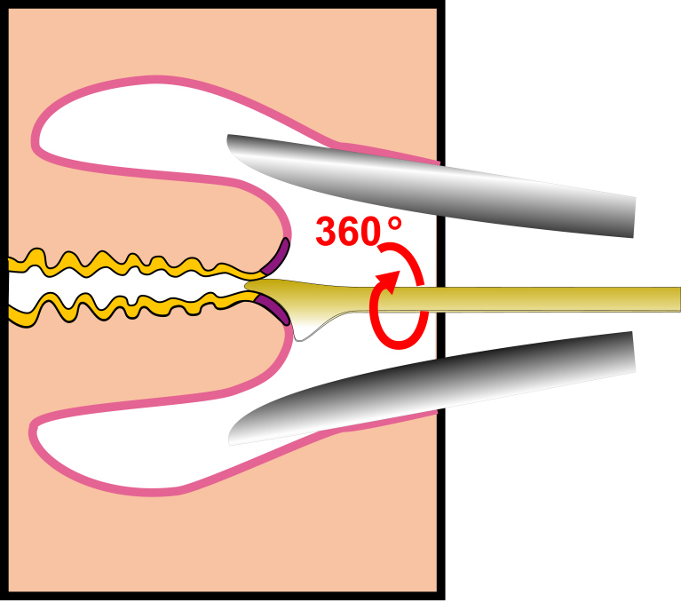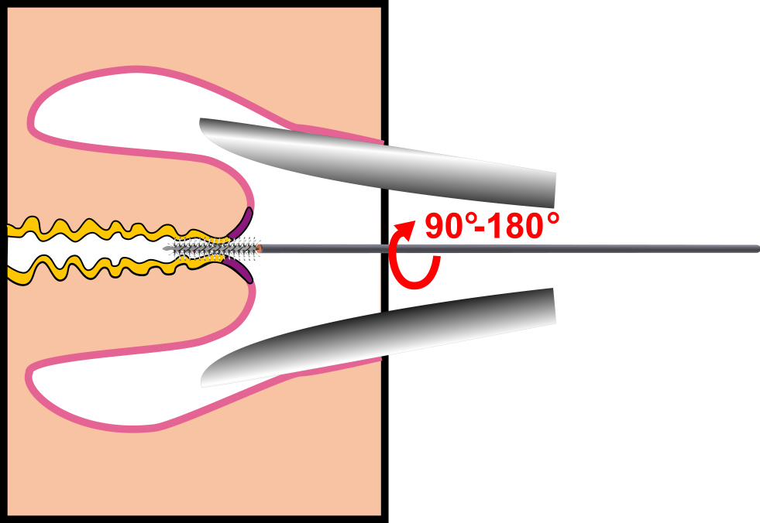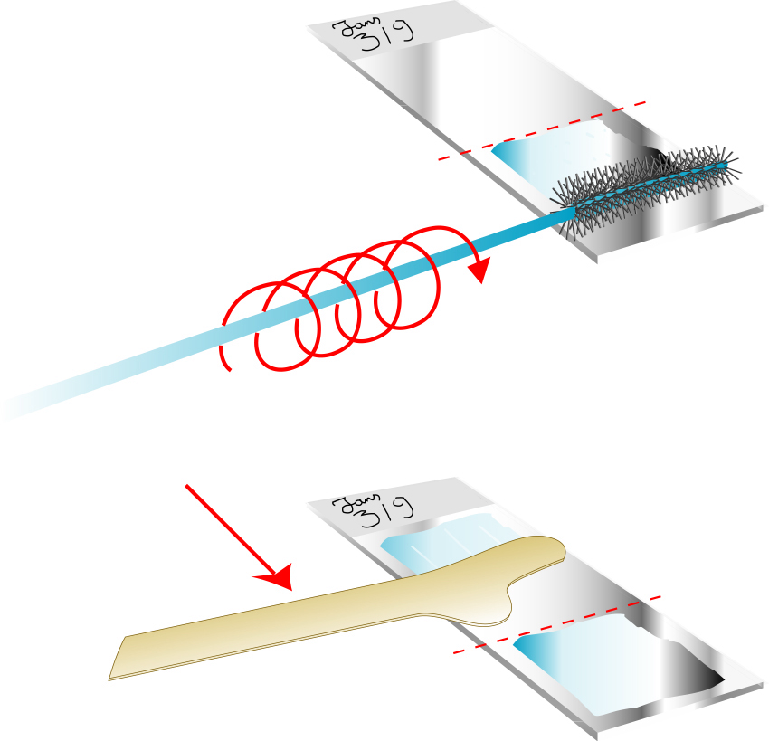
Figure 4. Sampling of cellular material using the combination of the spatula and the endocervical brush; spreading of both samples on one slide.

If a double sample is taken, which is rarely needed, spread it over two slides. First fix the spatula sample, before proceeding to endo-cervical sampling.

Preparing a liquid based cytology sample.
A liquid based cytology sample is collected from the cervix in the same way as that for a conventional smear but only plastic sampling devices may be used. The smear taker must follow the manufacturer’s instructions for collecting the sample. Either a single broom-like device or a combination of plastic spatula and endocervical brush are recommended for ThinPrep® while only a broom with a detachable head is recommended for the SurePath® system. The CytEasy® system recommends using a proprietary broom-like device.

The protocol for rinsing the sample into the vial of collection fluid depends on the methodology used and should be confirmed against the manufacturer’s instructions.

For the ThinPrep® and CytEasy® systems, the broom should be pressed vigorously against the bottom of the vial twenty times to remove all the cellular material. Before discarding the broom, the bristles should be inspected and the procedure repeated if any residual material is seen.

For SurePath® samples, the head of the broom is detached into the vial of collection fluid.

The lid of the vial should be firmly closed to prevent leakage during transportation. The ThinPrep Preservcyt® vial has torque lines to facilitate correct sealing. Over tightening of the lid should be avoided since this may impede functioning of the T3000 automated ThinPrep ® processor.

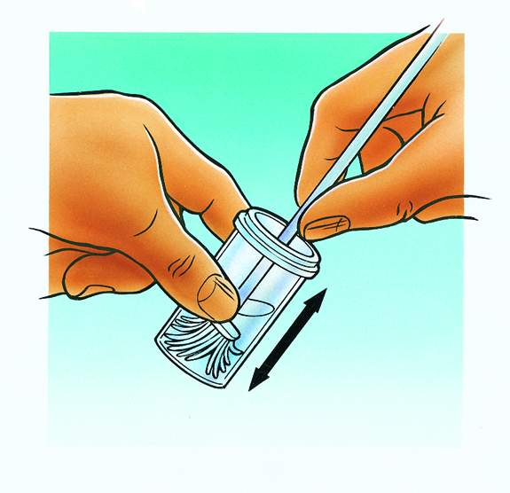

Figure 5. The broom is pressed multiple times vigorously against the bottom of the vial.

Transport to the laboratory and feed back

Transport to the cytology laboratory
After fixation, the specimen is allowed to dry completely. Then it is put into a cardboard or plastic holder for transport to the laboratory. A wet specimen can stick at the edges if it is put too quickly into the folder. The holder is labelled with identification details matching those on the request form.

Standard request form for cytology laboratory
Clinical details are important for accurate interpretation of a smear. The standard form (see Annex 1) is completed possible. The identification details required for recording the cytological data must be provided according to current instructions. It is indicated whether the result of the examination should be sent to another physician (for instance to the GP if the smear taker is a gynaecologist).

Feedback on the quality evaluation of the specimen
The cytological report on the smear, evaluated using the standard reporting system always includes an assessment of the quality of the smear. It is recommended providing every smear taker periodical summary reports of the quality evaluations of the smears he/she has taken compared with general distributions. This feedback, provided by the laboratory or a central register, should help to improve the average quality of smears.

Standard request form

Questions
- Bibliographic references necessary
- Provide explanation on the changes of cervical anatomy & histology
- Figure 5: look for an illustration from Surepath/AutoCyte
- Difference with the text of Euphemia & Julietta:
- If both the spatula or broom sample and the endocervical sample are placed on the same slide, care must be taken to ensure that the cells in the first sample are adequately fixed before taking the second sample and that these cells are not damaged while spreading the second sample.

For description of the evidence on which this guideline is based, see:

Buntinx F, Brouwers M. Relation between sampling device and detection of abnormality in cervical smears: a meta-analysis of randomised and quasi-randomised studies. BMJ 1996, 313, 1285-1290.

Buntinx F., Knottnerus J.A., Crebolder H.F.J.M., Essed G.G.M., Schouten H., 1992a. Relation between quality of cervical smears and probability of abnormal result. BMJ 1992, 304, 1224.

Martin-Hirsh P, Lilford R, Jarvis G, Kitchener HC. Efficacy of cervical-smear collection devices: a systematic review and meta-analysis. Lancet 1999; 354: 1763-1770.

Arbyn M. A Technical Guideline: Collection of Adequate Pap Smears of the Uterine Cervix. Final Report of the Working group Sampling. IPH/EPI-REPORT 2000-004, Brussels, Scientific Institute of Public Health.

This evidence can be worked explicitly. For the moment the sampling guideline is conceptualised as cooking recipe. To be further discussed.

