Annex 2 Propositions for a European cytological reporting system

(of Chap. 3: Methods and Techniques of Cervical Screening)

by U. Schenck, 12 pages

Work to do:
- send by usual mail or by email the Reporting Form used in your country in the daily work of cytological laboratories, practitioners, gynaecologists, etc.
(see in section 1 as an example the Portuguese form)
- dend by email (expertise@t-online.de) the comparison of your system (your reporting form and your cytological classification system) with the Bethesda system (maximal 5 pages)
(see in section 2 an example the contribution of A. Hanselaar for Holland).
- send your opinion about the general discussions on "Terminology"
(see section 3).

Responsibles:
Austria (R. Horvat)
Belgium (M. Arbyn)
Finland (A. Anttila)
France (J.-J. Baldauf)
Germany (G. Schott)
Greece (C. Zarogianni, P. Aristodimos)
Holland (H. Bulten, P. Klinkhamer, A. Hanselaar) ** work done, thank you ! **
Italy (G. Ronco, N. Segnan)
Portugal (O. Real, D. da Silva)
Spain (E. Zozoya, V. Herreros)
Sweden (J. Dillner)
United Kingdom (J. Jordan)

Table of Contents

- Example of Reporting Form from Portugal 150
- Example from Holland 151
Comparison of the Dutch system with Bethesda system
- Discussions on Terminology 155
- Conclusions 160

Example of Reporting Form from Portugal
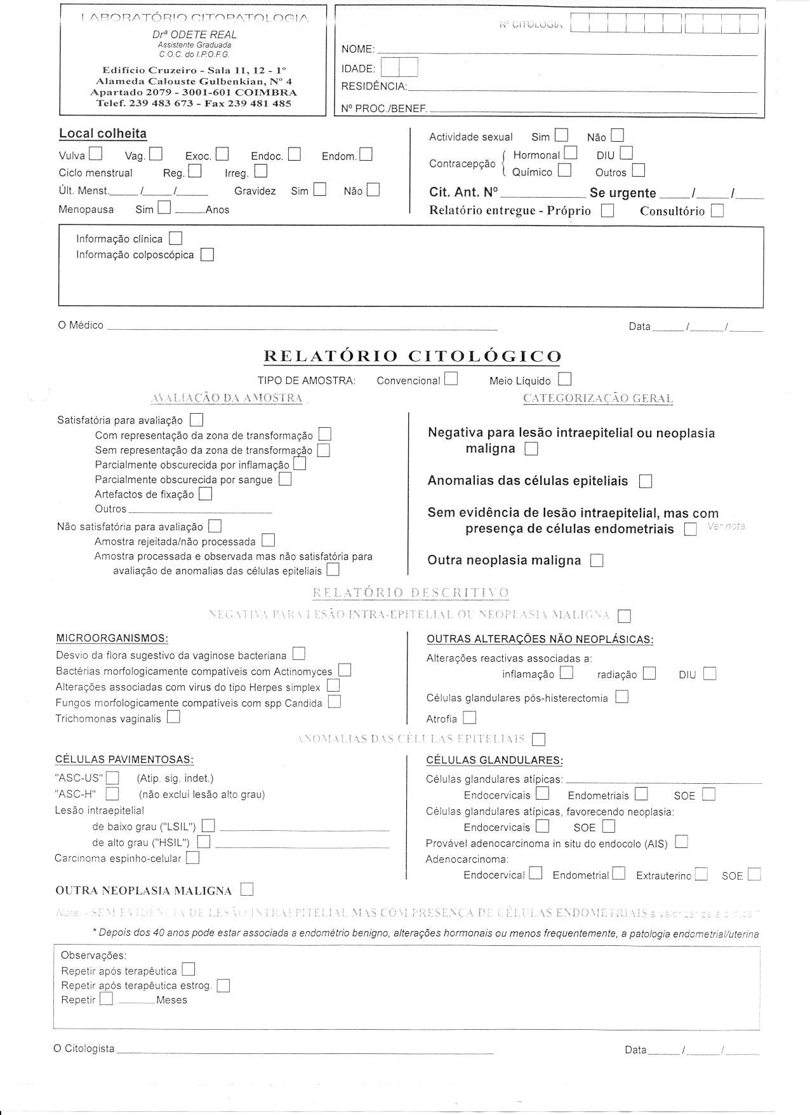

Example of Holland
Comparison of the Dutch system with Bethesda system

We present in this section the paper of 4 pages "Towards a common European classification and coding system for Pap-smears" of 28. September 2002 of A. Hanselaar (University of Nijmegen and Dutch Cancer Society).

With the Pap-smear test a simple, innocuous, and effective diagnostic-test is available. Cytology, which must be performed under strict quality assurance and control protocols, can give a considerable reduction in the incidence and mortality of cervical cancers in a population if all women attend and all detected lesions are adequately followed up.

Common European coding and classification criteria for cytology should be implemented.
The cytological diagnosis of abnormal cells in a smear is a subjective procedure that depends on the quality of the smear and of the capability and experience of the examiner and also depends on the time that is being given to the preparation and examination of the smear. Cytological diagnosis of the uterine cervix can impossibly be carried out without errors. Several systems for the classification of Pap-smears have been described. The Bethesda System in the United States has contributed to the assessment of the adequacy of the specimen; it uses standardized diagnostic terminology and makes recommendations. In Europe several national and local systems are used which have a large overlap in diagnostic categories.
There exists a need to combine the strong aspects of these systems to create one European-classification system. Such a system might still use local-national terminology, but should be computer-coded in the same way. Furthermore uniform classification criteria should be agreed upon. Finally in order to facilitate evaluation at all levels of screening programs agreement should exist on the contents of an aplication form for screening purposes.

Netherlands Classification system
In the Netherlands a uniform application form (figure 1) and a standardized cytological classification system, which contains six sections (CISOE-A; table 1), are used.
In table 2 a comparison is given of the CISOE-A system and the Bethesda system. The CISOE-A system forms the basis of a systematic examination and standardized coding of the smears. All pathology laboratories in the Netherlands store the results in the automated pathology archive, PALGA, according to a standardized cervix registration and information system. Hereby national, regional or local evaluation is possible.

Figure 1. National Netherlands application form for cervical cytologic examination.

Labnumber: ........-........
Date of receival: ......../......../........

CYTOPATHOLOGICAL EXAMINATION OF THE CERVIX*

Date of birth : Registration no. :
Name :
Initials :
Place of birth/ :
Native country :
Home address :
Residence : Postal code :
Insurance company : Registration number :

Name doctor :

1. Date of smear ..../..../....

2. Indication smear; screening
0 1 program invitation
0 2 repeat after inadequat

3. Smear by
0 1 family doctor
0 2 gynecologist
0 9 otherwise: .........................

4. Instrument smear
0 1 cervexbrush
0 2 cytobrush and spatula
0 3 spatula
0 9 otherwise: .........................

5. Complaints
0 0 none
0 1 abnormal loss of blood
0 9 otherwise: ........................

6. Date of menstruation ..../..../....

7. Menstruation pattern
0 0 none
0 1 regular
0 2 irregular
0 3 (post)menopausal (>1 year
no menstruation)
0 9 otherwise: ………………..
0 x unknown

8. Contraceptive
0 x unknown
0 1 hormonal
0 2 IUCD
0 9 otherwise: ..................
0 x unknown:

9. Use of hormone
(otherwise than contraceptive)
0 0 no
0 1 yes: ....................
0 x unknown:

10. Remarks
0 0 no
0 1 yes: ....................

11. Indication smear; medical indication
0 3 (gynecological) complaints/symptoms
0 4 repeat smear
0 5 DES-daughter
0 6 on request by the patient
0 9 otherwise: .........................

12. Surgery of the cervix
0 0 no
0 1 cryo, or laser
0 2 conisation, leep excission, biopsy
0 3 supravaginal uterusextirpation
0 5 radiotherapy
0 6 combination, nl:
0 9 otherwise: ...
0 x unknown

13. Aspect cervix
0 1 normal
0 2 not seen
0 3 abnormal\suspect portio

14. Pregnancy
0 1 Pregnancy, .... weeks
0 2 post partum, .... weeks
0 3 lactation, .... weeks
0 4 postlactation, .... weeks

Table 1: The Netherlands CISOE-A system.

 | C | I | S | O | E
 | Composition | Inflammatory changes | Squamous  Epithelium | Other changes/ endometrium | Endocervix cylinder epithelium/
0 | Insufficient | Not applicable | Not applicable | Not applicable | Not applicable
1 | Endocervical cells present (EC) | Virus infection | No changes | No other changes | No changes
2 | Squamous metaplastic cells present (SM) | Trichomonas vaginalis | Abnormal squamous cells | Epithelium atrophy | No endocervical epithelium
3 | Endometrium (EM) present | Bacterial infection | Atypical squamous metaplasia | Atypical repair reaction | Few atypical endocervical cells
4 | EC + SM cells present | Candida albicans (monilia) | Mild dysplasia | Mild atypical endometrium | Mild atypical endocervical cells
5 | EC + EM cells present | Haemophilus vaginalis (gardnerella) | Moderate dysplasia | Moderate atypical endometrium | Moderate atypical endocervical cells
6 | SM + EM cells present | No signs of inflammation | Severe dysplasia | Severe atypical endometrium | Severe atypical endocervical cells
7 | EC + SM + EM cells present | Actinomyces | Carcinoma in situ | Adenocarcinoma endometrium | Adenocarcinoma in situ endocervical epithelium
8 | Only squamous cells | Chlamydia | Micro-invasive squamous cell carcinoma | Metastasis malignant tumor | Not applicable
9 | Not applicable | Non-specific inflammation | Invasive squamous cell carcinoma | Not applicable | Adenocarcinoma of the Endocervix

A
Adequacy
1 | Adequate
2 | Sufficient but limited by (problem typing)
3 | Not adequate caused by (problem typing)

Adequacy problem typing
- much blood f) cytolysis
- many leukocytes g) thick smear
- little epithelial cells h) few squamous cells and many endocervical cylinder cells
- bad fixation j) no endocervical cylinder cells
- mechanical damage
Table 2: Comparison of the Netherlands CISOE-A system with Bethesda system.

CISOE-A class (8) | Bethesda- class (23)
S2-3, E3 | ASCUS/AGUS
S4, E4, E5 | LSIL
S5 | HSIL
S6, E6 | HSIL
S7, E7 | HSIL/AIS
S8, S9, E9 | (micro-)invasive squamous cell / adeno-carcinoma

Table 3: Advises for repeat smear or referral to gynecologist for colposcopic evaluation

“CISOE-A Classes” | Abnormality | Advise | Follow-up advise
S1, O1-2 | normal | 5 year
S2-4, O3, E3-5 | minor abnormality including ASCUS, LSIL | 6 months | Normal → 12 months; 2x normal → next screening invitation  Abnormal → gynecologist
S5-7, E6-7, O4-6 | more severe abnormality including HSIL | Gynecologist | After treatment, repeat after 6-12-24 months  After no treatment, repeat after 6-12 months
S8-9, E9, O7-8 | carcinoma | Gynecologist | After treatment, repeat after 6-12-24 months
A2j | no endocervical and/or squamous metaplastic cells present | 6 months | After 2x A2j, → next screening invitation
A3 | not adequate | 6 weeks

Discussions on Terminology

We present in this section the paper of 6 pages "Discussion of ECCSN Terminology Group" of 26. February 2003 of U. Schenck which summarises the general discussions on "Terminology". The general discussions of the terminology for uniform reporting schemes will be continued within the Network, and also with experts outside of the Network.

Aim: To cover diversity of Reporting Schemes in Europe and provide a basis for comparability of data collected from the European Cervical Cancer Screening Programs and for a future development of a Uniform Reporting in Europe.

Overview

Lack of uniform terminology and reporting in cervical cancer screening programs is a major drawback for the organisation of cervical cancer screening programs and the international comparison of data. The report scheme presented here can be used as report scheme in cytology labs, where no official national report scheme is in practise. Where national report schemes are in place, this report scheme may be implemented into screening laboratory software as a hidden layer to guarantee for uniform data collection for quality assurance. It is presumed that all cervical cytology screening labs use specialised software implementing report administration and quality assurance. While national report schemes will persist, since report schemes are a major factor in the distribution of medical resources, this report scheme should be considered as a basis allowing for translatability of cytological findings among diverse schemes like those in practise e.g. in Austria, Germany, the Netherlands, the United Kingdom and the United States of America.
To cover the diversity of report schemes this scheme has more options than will necessarily appear in a the cytological report. So, part of the report scheme presented here is optional like reporting on microbiology. While understanding hormonal influence on the vaginal epithelium is absolutely necessary in the daily cytological practise, hormonal evaluation is not part of the report.

Definition of terms

There is no restriction concerning the addition of free text components, where this is the local or regional choice. It is also local choice to add educational comments or “disclaimers”. If not otherwise stated, the report is based on a visual evaluation of a Pap-stained one slide smear preparation.

Like in a histological report procedures should be specified, documented and commented where needed. This would include a documentation of what was received, the type of specimen smear vs. liquid medium, the staining Papanicolaou versus other, and the type of slide reading visual screening by health professional versus automated slide reading with specification of the system. Vaginal smears after hysterectomy should be clearly marked separately, provided the clinical information is given.

Following abbreviations are used below:
ADQ: Adequacy
COMP: Composition
CAT: Categorisation
LES: Lesion
EME Endometrial
ECE Endocervical
REC: Recommendations
MIC: Microbiological

ADQ Statistical groups concerning Adequacy

Explanation: Concerning adequacy there are two basic options: Satisfactory or Unsatisfactory. On a national or regional form, presence or absence of squamous and endocervical cells would appear in the cellular composition field. It has been suggested to replace the terms satisfactory and unsatisfactory by suitable and unsuitable. For slides that are “unsatisfactory / satisfactory but limited by...” a comment whether this is patient or smear-taker related or a combination of the latter might be added. In any case the significance of a compromised sample concerning the representativity of the material remains a question for the smear-taker.

- Satisfactory for evaluation / or satisfactory but limited by..
- Satisfactory for evaluation
- Satisfactory for evaluation but limited by lack of Endocervical / Transformation zone component.
- Satisfactory for evaluation but limited by other than lack of endocervical cells (specify reason)

- Unsatisfactory for cytological evaluation
- Specimen rejected/not processed (specify reason)
- Specimen processed and examined, but unsatisfactory for evaluation of epithelial abnormality because of (specify reason)

COMP Epithelial Cellular Composition

Explanation: In all settings of cytological practise the cellular composition of the slides is evaluated. Still the result may not appear in the report explicitly. By recording the cells at least at the cytological reading level statistical anaIysis is possible.

- Squamous cells present. Option: Indicate the prevailing cell type: 1=Parabasal cells, 2= Small intermediate cells 3= Large intermediate cells 4= Superficial cells
- Endocervical / Transformation zone component present
- Endometrial cells present (Compare Chapter EME)
- Other Cell types

CAT General categorisation of the smear concerning neoplastic changes:

Explanation: A “general categorisation” would be essential for report schemes in European Screening Programs. It separates the cases of “No malignant or suspicious cells found” from all other cases “Suspicious or lesional Cytological Findings”

Among the cases of “no malignant or suspicious cells found” the subdivision in “Normal / Within normal limits” and “Benign cellular findings (specify)” may be skipped or put into a hierarchic order. “Smears suggesting a limited protective value (e.g. subdysplastic, i.e. less than mild dysplasia)” as a subgroup of no malignant cells found, would comprise cases with some nuclear enlargement, as a rule of mature squamous cells or in atrophy etc. Such cases might need an early repeat.

- No malignant or suspicious cells found
- Normal / Within normal limits
- Benign cellular findings (specify)
- Smears suggesting a limited protective value (e.g. subdysplastic,less than mild dysplasia)

- Suspicious or lesional Cytological Findings
- Suspicious cells possibly deriving from a lesion more severe than mild squamous dysplasia. (See subclassification)
- Findings suspicious for an intraepithelial lesion (See subclass.)
- Findings suggestive or diagnostic of invasive cancer (See subclass.)

LES Subclassification of Lesions in the Cytological Report

Explanation: Cytology of squamous intraepithelial lesions is well defined though subjective. Cytology suggestive of mild dysplasia is frequently followed by negative follow up which can indicate both regression of a lesion or limitations of the test in the initial diagnosis or in the follow up. Separation of severe dysplasia from carcinoma in situ needs not to be performed. In these cases regression to normality cannot be expected. Cytology suggestive of CIN2 is in between. Even if cellular findings may be typical, formulations like “suggestive of CIN1” or “severe dyskaryosis” indicate that discrepancies with the morphological correlate at the cervix necessarily occur. Expected type and magnitude of such error are the basis for risk management to balance risk of under and over treatment. Cases with typical HPV findings are to be classified with the squamous intraepithelial lesions.

Glandular cervical lesions: While adenocarcinoma in situ (AIS) of the cervix is accepted as a diagnostic entity that can be diagnosed by cytology in some cases, existance and classification as well as the capability of cytology for the diagnosis of cervical cervical glandular lesions below the level of adenocarcinoma in situ is still under debate. While this option is offered here to allow for future evalutation, these cases are to be considered at the same time as classified as “atypical endocervical glandular cells”.

Intraepithelial Lesion, Dysplasia /Carcinoma in situ, Cervical Intraepithelial Neoplasia.

- Findings suspicious for an intraepithelial lesion
- Findings suspicious for a squamous intraepithelial lesion
- Suggestive of mild dysplasia CIN I Low grade SIL
- Suggestive of mod. dysplasia CIN II High Grade SIL
- Suggestive of sev.dys. / CIS CIN III High Grade SIL

- Findings suggestive of a cervical glandular intraepithelial lesion
- (Findings suggest. of “low grade GIL”)
- (Findings of intermediate of GIL)
- Findings suggestive of Adenocarcinoma in situ (AIS)

Atypical / Suspicious cells possibly deriving from a lesion more severe than mild squamous dysplasia.

Explanation: While the vast majority of cervical specimens can be classified based on characteristic findings, all report schemes have to provide for cases showing epithelial cell abnormality that can not be attributed to a certain type of lesion or even type of epithelium. The cytopathologist is asked to give a short clear text comment to such cases in addition to the grouping for statistical purposes. The cytopathologist must be prepared to discuss the cytological problem with the physician who is in charge of the patient management. Referral with loss of such relevant information may lead to over diagnosis or under diagnosis. The use of recommendations in European screening programmes is one of the approaches to deal with such cases.

Since such categories as “Class III”, “borderline”, “ASCUS”, “AGUS” etc. have been introduced the poor reproducibility is well known. Also the group of such cases cannot be addressed properly without looking at the complete group of non-negative reports. The same smear might be grouped differently according to local practise as negative, atypical or unsuitable, still the logistical procedure (e.g. a repeat smear) might be the same.

Atypical changes must be separated according to the cell type wherever possible. Separating atypical glandular cells of cervical and endometrial origin is essential, since the follow up is totally different. Risk for certain lesions should be addressed.

- Atypical / suspicious cells possibly deriving from a lesion (more severe than mild squamous dysplasia)
- Atypical squamous cells
- Atypical squamous cells (Lower risk / favour reactive)
- Atypical squamous cells ASC-H (“cannot exclude CIN 3”)
- Atypical squamous cells of undetermined signifi.(ASC-US)
- Atypical squamous cells (NOS)

- Atypical glandular cells

- Atypical endocervical cells (ECE)
- Atypical endometrial cells (see EME)
- Atypical glandular cell (NOS)

- Atypical cells (NOS)

Cancer diagnosis
- Findings suggestive or diagnostic of invasive cancer
- Probable invasive cancer (carcinoma in situ “cannot be excluded”)
- invasive cancer of any type

Cell type of cancer cells
- Squamous cell cancer
- Adenocarcinoma
- Carcinoma NOS
- Other malignant Neoplasms

Suggested primary site
- Uterine cervix
- Uterine corpus
- Ovary
- Other

EME Reporting on cells of endometrial origin

Endometrial cells: this is a partly duplication to demonstrate the typical options. In the cellular composition of the smear endometrial cells may be reported whenever seen without any age restrictions.

- No cells of endometrial origin found
- Endometrial cells present (Compare Chapter COMP)
- Normal appearing endometrial cells
- Normal appearing endometrial cells without adequate clinical information
- Normal appearing endometrial cells in a postmenopausal woman
- Atypical endometrial cells (see also atypical cells)
- Suspicious endometrial cells not allowing a definitive diagnosis of endometrial adenocarcinoma (see also atypical cells)
- Cellular findings of endometrial adenocarcinoma (see also cancer diagnosis)

REC Statistical groups of recommendations:

Explanation: Statistical groups concerning recommendations are essential in European screening programmes. The definition of the groups is different in countries with different health care system.

- Repeat in standard screening interval (No further action needed)
- Any further action suggested
- Early repeat for cellular findings
- after treatment of inflammation
- after hormone application)
- Repeat due to unsatisfactory / less than optimal smear
- Other further actions needed
- Referral
- Histology

MIC Microbiological Findings

Explanation: Microbiology will be considered as an option in many countries. It is included in this scheme to create comparability of data where microbiology is included in the reports. It is conceded that also the normal may be reported i.e. Döderlein Flora. HPV is also included under microbiology. This would create translatability if in a region or on a national level a CIN1 lesion with koilocytes would be classified as negative with “wart virus”. As a rule cases with HPV related findings like koilocytes will be lumped with CIN according to the degree of cellular and nuclear abnormality. Concerning intraepithelial lesions and cancer of the cervix which are closely related to HPV infection these would not be mentioned among the microbiological findings.

Bacterial Findings

- Döderlein Bacilli
- Other bacteria
- Shift in flora suggestive of bacterial vaginosis
- Bacteria morphologically consistent with Actinomyces spp.
- Other, specify:
- No visible bacterial Flora

- Other organisms or indicators of infection
- Eukaryotic microorganisms
- Fungal organisms morphologically consistent with
Candida spp.
- Tricomonas vaginalis
- other

- Epithelial changes associated with viral infections
- Cellular changes associated with Herpes simplex virus
- Cellular changes associated with HPV

Conclusions

The Uniform Reporting Scheme in Europe will facilitate the correct comparison of health care data in Europe, with the aim of promoting the best practices in cervical cancer diagnosis and treatment in different European regions.

The aim of this discussion paper is not to replace the existing cytological reporting system in each European country, but to provide the base for correctly understanding and comparing the existing systems, and for their long-term improvement.

In this way the efficiency and accuracy of reporting schemes can be improved in each European country, in accordance with existing practices.

