Chapter 4: Laboratory guidelines for cervical screening

Subchapter 4.2: Computer-based quality control

Software in Portugal for quality assurance in the screening lab
by Odete Real, 3. March 2003, 5 pages

Programa de Rastreio do Cancro do Colo do Útero
Cervical Cancer Screening Programme
QUALITY CONTROL

Internal Quality Control

1. Collecting the smears (Assessment of the quality of smears. Training is recommended for doctors with a high number of unsatisfactory smears).
2. Processing (Preparation and Staining)
3. Screening.
Smears must be screened by qualified observers, with specific training.
Second review is compulsory for all smears with:
- Abnormal findings relevant clinical information,
- previous abnormal cytology or histology,
- abnormal cytology with unconfirmed histology
- relevant pathology and previously negative cytology.
- Cytological, colposcopic and histological results must compared, and ambiguous cases discussed. All abnormal results and difficult diagnoses are reviewed by the cytopathologist.
- Slides and copies of the request forms are all filed accordingly (External Quality Control). There is an exchange of slides with other laboratories and continual education.

Quality Control MODULE

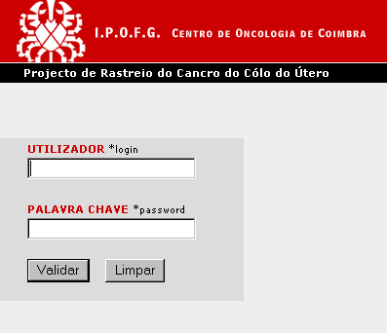

QUALITY CONTROL
Quality Control module enables the control of the results of the cytological exams made by the technicians.
To generate the exams to be analyzed for Quality Control one must specify the period of time, the quantity of smears, the technicians that will reexamine the smears and, finally, how to choose the smears - by cytological diagnosis or by the smear quality.

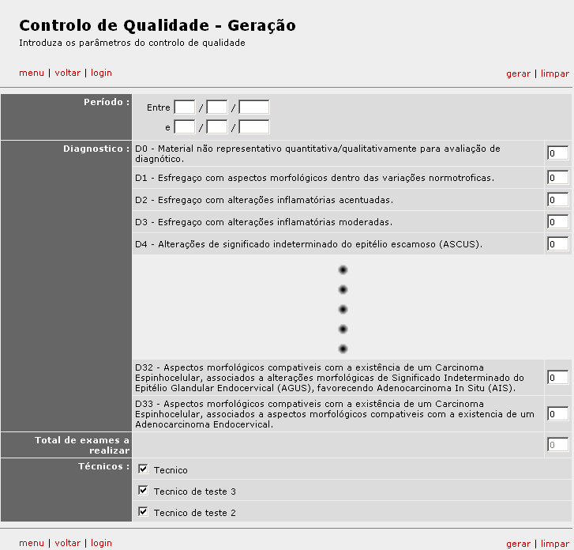
Figure 1 – Generation of exams to be reexamined, by cytological diagnosis
By clicking in Generate (‘gerar’), the exams with the characteristics chosen will be randomly selected for the quality control test, and assigned to one of the specified technicians.
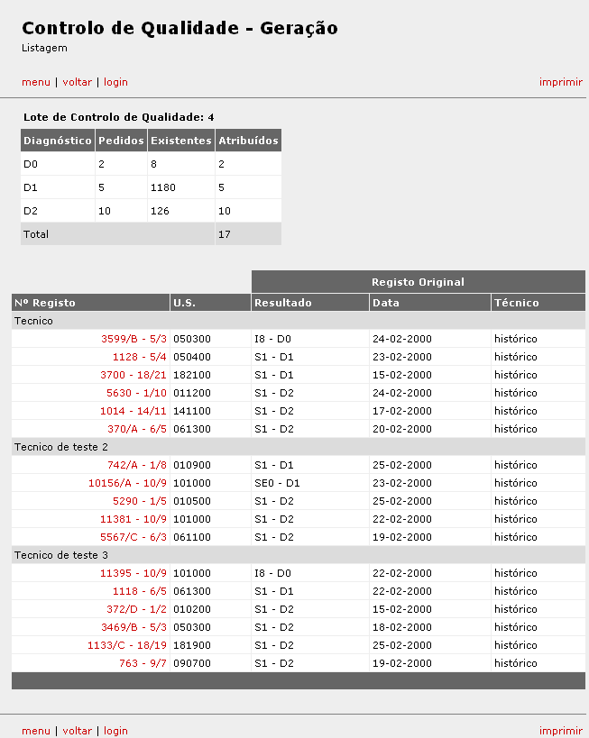
Figure 2 – Result of a quality control generation
The result of the Quality Control Generation lists all the cytological exams that entered the Quality Control path, showing the original result and technician, together with the technician who will be responsible for the new examination. As this page contain sensible information, it can only be viewed and printed by the Master Technician. Due to restrictions in the information that can be viewed, the printed list that is delivered to each one of the technicians responsible for the reexamination only shows their name and the information needed to identify the smear. Information about previous result or technician is not showed.
The screen Quality Control Visualization permits to control the results of the new evaluation, comparing the new results with the original ones. If the result differs the new result becomes red.

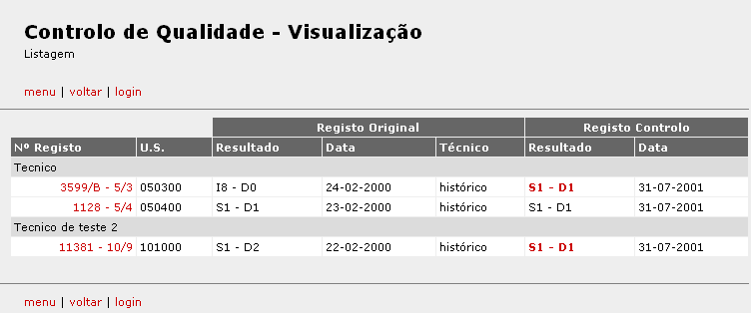
Figure 3 – Quality Control Visualization
It is possible to select one exam in particular by clicking its number. The result is showed in the next figure.
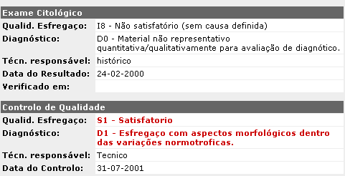
Figure 4 – Screen showing details about the original cytological exam and the one produced by the Quality Control (the red color indicates that they differ).

After analyzing the Quality Control results the Master Technician can re-evaluate the smears that have different results and alter the original result.

