Helsinki sightseeing tours
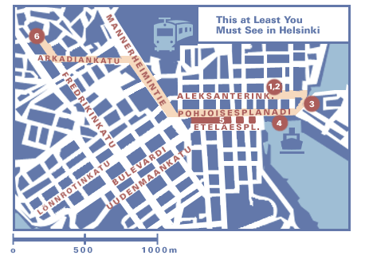
On-foot tour, 2-3 hours

If you want to use your time in Helsinki as economically as possible, here are some suggestions as to how you can get the most out of a day or half day.
The place that we list here have been chosen because they are all within walking distance of each other. You can combine various alternatives and choose the timing of your visit to suit yourself. Most of the places we mention have links to pages with more detailed information about hours of opening and so on. Our time planning is based on the assumption that an hour or so is enough to at least get the feel of a museum, whilst 15-30 minutes is enough for a church.
The "This at Least You Must See in Helsinki" tour:
Senate Square - Lutheran Cathedral - Uspenski (Orthodox) Cathedral - The Market Square - Esplanadi (linear park) - Temppeliaukio Church ("The Church in the Rock")
You’ll need at least two hours for this.
The tour begins at the Senate Square, beside which the Lutheran Cathedral soars above a splendid ensemble of buildings in the variant of Neoclassical architecture called Empire. From there you continue up to the end of Aleksanterinkatu and on to Uspenski Cathedral. Then back past the Market Square to Pohjoisesplanadi, the street running along the north side of the linear park. At Mannerheimintie, the city’s main thoroughfare, you turn right and continue to the Lasipalatsi ("Glass Palace") and the Museum of Contemporary Art Kiasma, then left into Arkadiankatu and on to Fredrikinkatu. Turn right at the intersection and walk up the hill about 200 metres to Temppeliaukio Church.

Tour by Tram 3T, 45 minutes
Without doubt, the least expensive sightseeing tour you can take is in the 3T tram. You need no guide, and there is not the slightest danger of your getting lost in a strange city. That is because the tram runs in a figure-8 loop through and around the centre of the city and in 45 minutes or so takes you right back to the place where you boarded it. The sights and stops along the route are announced (in Finnish, Swedish, English and German) on an electronic display panel during the summer months and you can get a brochure with the same information and a map in the same languages. Remember that it is the 3T tram, because there is also a 3B, which follows the same route, but in the opposite direction.
You can get on at any stop, such as the Market Square, where the charming fountain statue of the pretty mermaid Havis Amanda watches all the bustling commerce and colour. From there the tram runs up a narrow street and turns into the famous Senate Square. Then it proceeds down the lively pedestrianised shopping street Aleksanterinkatu and along Mannerheimintie towards Töölö.
The sights along the route include the new Opera House, the Olympic Stadium, Linnanmäki amusement park and the Railway Station. Near the Station the tram passes the Ateneum art museum and then proceeds towards South Helsinki and Kaivopuisto Park, where there are many embassies and ambassadorial residences. Then it passes the Olympia ferry terminal, where large ships arrive from and depart for Sweden and Estonia. Only a few hundred metres later, you are back at the Market Square.
That whole sightseeing tour will cost you only 1,70 €, unless you want to continue travelling on another line. Then the fare is 2 €, which entitles you to change lines as often as you want within one hour.

